31. Query to display the total number of supervisors without listing their names.

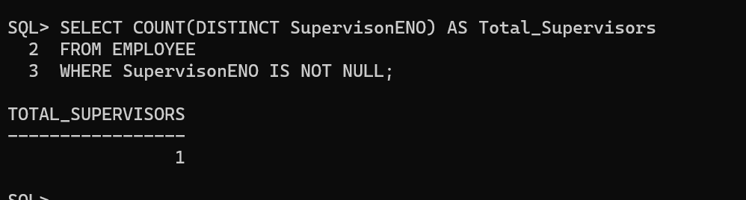

32. Query to display the Department Name, Location Name, No. of Employees and the average salary for all employees in that department.

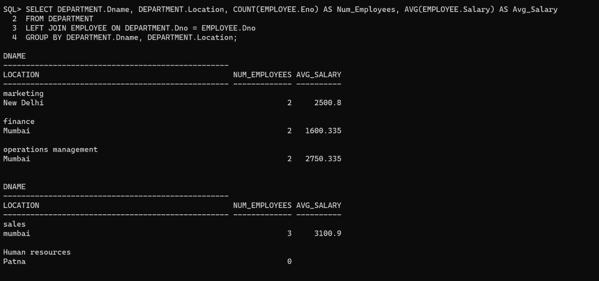

33. Query to display Name and Hire Date for all employees in the same dept. as piyush raaj.

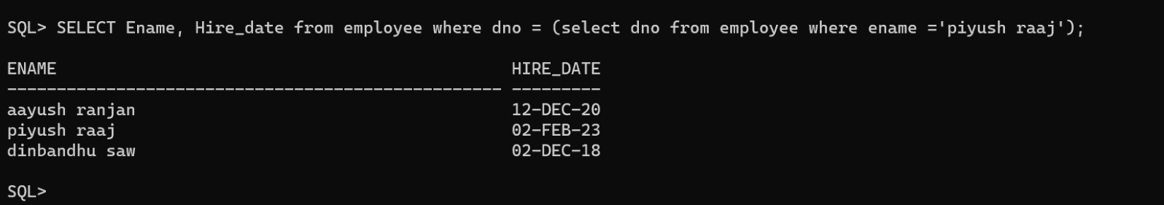

34. Query to display the Employee No. And Name for all employees who earn more than the average salary.

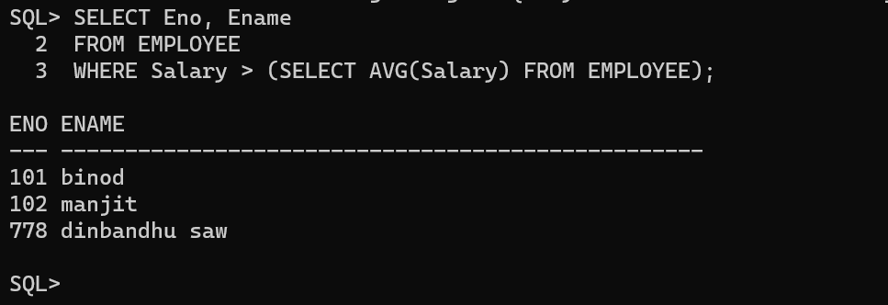

35. Query to display Employee Number and Name for all employees who work in a department with any employee whose name contains a ‘t’.

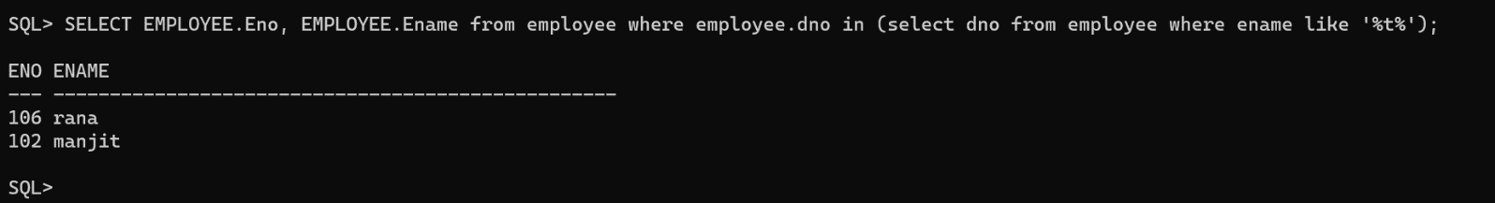

36. Query to display the names and salaries of all employees who report to supervisor named ‘dinbandhu saw’.

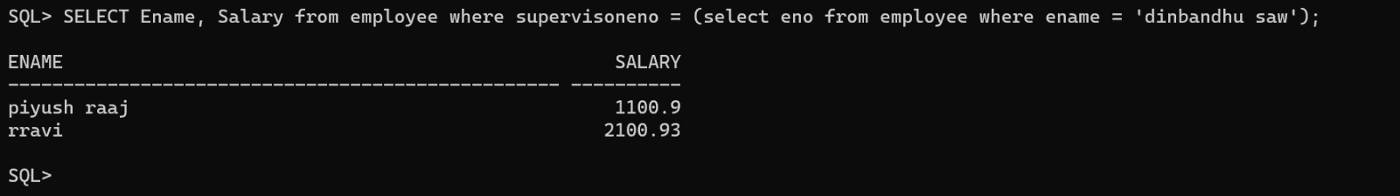

37. Query to display the department no, name and job for all employees in the Sales department

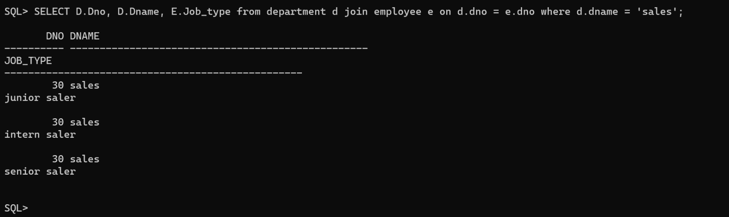

38. Display names of employees along with their department name who have more than 5 years experience

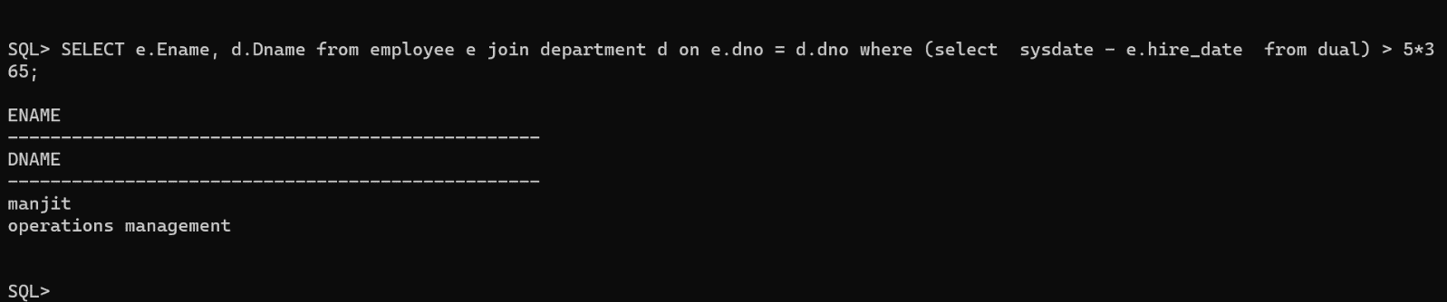

39. Display total number of departments at each location

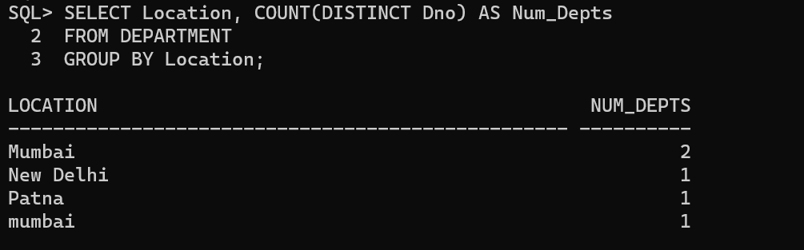

40. Find the department name in which at least 2 employees work in.

